Student Self-Service Proxy Access
Students can grant access to their accounts from within Self-Service using the “View/Add Proxy” feature. This allows other people, called “Proxies”, to access to the student’s records for things like:
- Viewing student statements
- Making a payment
- Viewing grades
To grant someone else Proxy access to your student account in Self-Service:
- Login to SelfService from OneLogin.
- Click on your username in the top right corner and choose “View/Add Proxy Access”
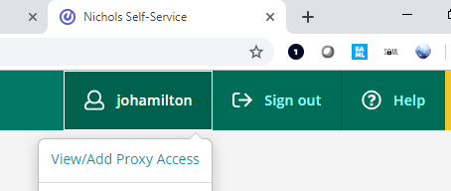
- If you have any existing Proxies, they are listed under “Active Proxies”. You can come to this page at any time to edit access for your existing Proxies.
- To add a new Proxy, choose the person from the “Select a Proxy” drop-down. If the person isn’t listed, choose “Add Another User” and fill in the name, email, and other information about the person.
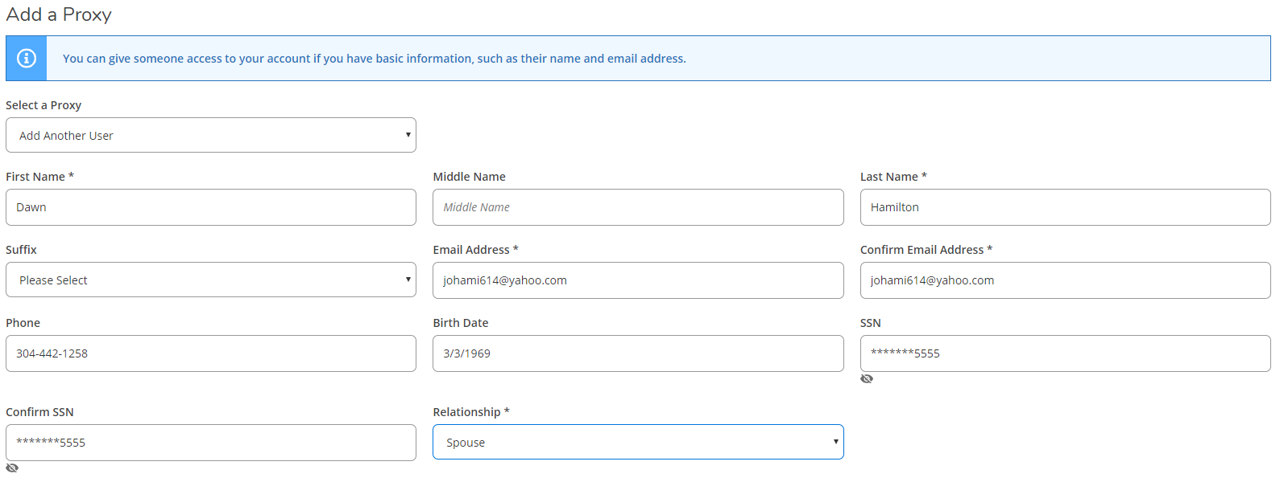
- Choose the level of access you want the Proxy to have by checking the appropriate boxes.
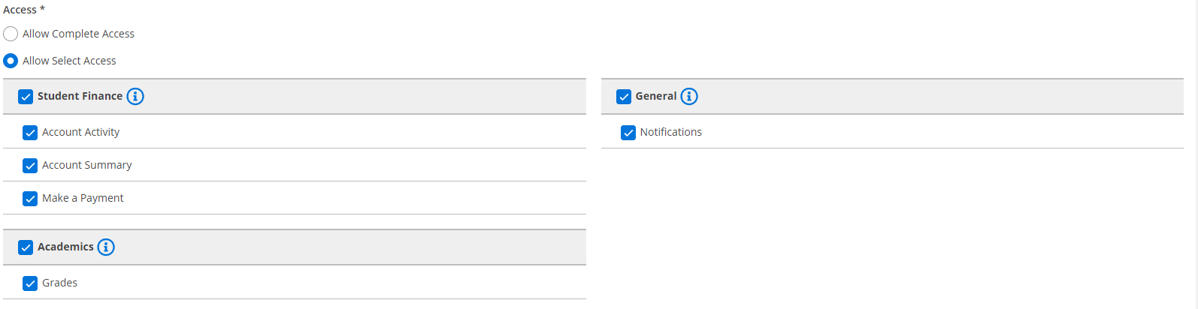
- After reading the Disclosure Agreement, check the box below and click Submit.
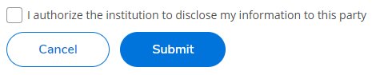
- You will then see a confirmation message stating whether or not the Proxy user was found in our system; click Continue to give the user access or Cancel to go back.
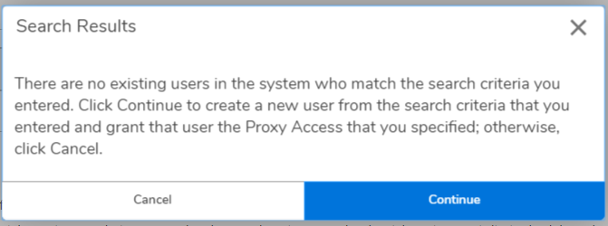
- The Proxy will receive an email with their username and instructions for resetting their initial password and accessing your records in SelfService; you will also receive a copy of this email as confirmation that access has been granted.
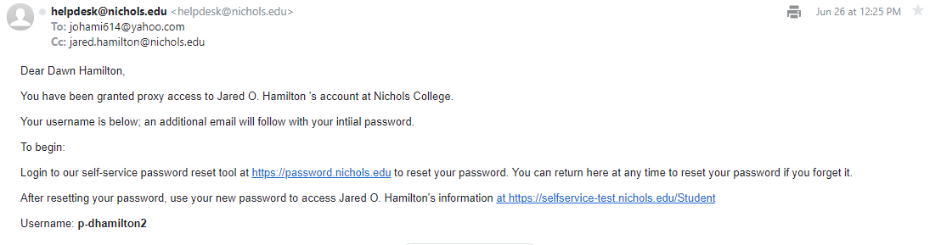
- Your Proxy will receive a second email with their initial password. For security reasons, you will not receive the password via email.
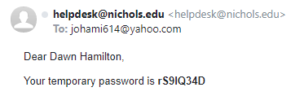

IMPORTANT NOTICE
You must follow this process even if you granted Proxy in our prior system, Nichols.afford.com

